Baker Hughes
OpenShift Platform for Containers and Virtualization in Disconnected Environments

High Level Design

Prepared for: Baker Hughes
Project Number:
Version 1

Rawad Sabbar
OpenShift Architect | Red Hat Cloud Platform Practice

Confidentiality, Copyright, and Disclaimer
This is a Customer-facing document between Red Hat, Inc. and Baker Hughes.

Copyright 2024© Red Hat, Inc. All Rights Reserved. No part of the work covered by the copyright herein may be reproduced or used in any form or by any means – graphic, electronic, or mechanical, including photocopying, recording, taping, or information storage and retrieval systems without permission in writing from Red Hat except as is required to share this information as provided with the aforementioned confidential parties.
This document is not a quote and does not include any binding commitments by Red Hat.

Trademarks
Trademarked names may appear throughout this document. Rather than list the names and entities that own the trademarks or insert a trademark symbol with each mention of the trademarked name, the names are used only for editorial purposes and to the benefit of the trademark owner with no intention of infringing upon that trademark.

Review History

Version | Date | Contributor | Description
1 | 03/31/2026 | Rawad Sabbar | Initial draft

1. Introduction 3
1.1. Purpose 3
1.2. Scope 3
1.3. Audience 4
1.4. Terms and Acronyms 4
1.5. Referenced Documents 5
2. High Level Overview 6
2.1. Navigate Objective 6
2.2. Requirements 6
3. Platform Architecture and Design 10
3.1. Architectural Design Decisions 10
3.2. Solution Overview 13
3.2.1. Deployment Architecture and Platform services 13
3.2.2. Cluster Cluster Topology and Node Roles 14
3.2.3. Physical Infrastructure and High Availability Design 14
3.2.5. Network Design and Capacity Planning 15
3.2.6. Platform Storage 15
3.2.7. Load Balancing 16
3.2.8. Software Editions and Subscriptions 17
3.2.9. Future Considerations 17
3.3. OpenShift Cluster Deployments 18
3.3.1. Node Networking Customizations 18
3.3.2. Bare Metal Machine Management 19
3.3.2.1. Node Maintenance 20
3.3.3. Workload Availability 20
3.4. Quay container registry 21
4. Disaster Recovery and Site Failover 22
4.1. Integration and Data Protection Strategy 22
4.2. Snapshots for Point-in-Time Recovery (Local Site) 22
4.3. Disaster Recovery Scope (Local Site Only) 22
4.4. Namespace-Level Backup and Recovery 22
5. Virtual Machine Workloads and Migration Planning 23
5.1. Migration Planning 24
5.1. Virtual Machine Health Checks 24
6. Appendix 32

1. Introduction
Red Hat has been engaged by Baker Hughes to design and implement a new platform solution based on Red Hat OpenShift Container Platform, along with developing the supporting artifacts that define the desired end-state architecture.

The proposed platform will provide application teams with a hypervisor-based environment for running both containerized and virtualized workloads using OpenShift Virtualization. Although this environment is intended for non-production use, the core design patterns will be aligned with the target production environment to ensure consistency and a smooth transition to production.

The platform will be deployed in a fully disconnected (air-gapped) manner. As part of this design, a mirror registry will be implemented to host required container images locally. This mirror registry will be deployed on a virtual machine running on a RHEL host that serves as the underlying hypervisor.

1.1. Purpose
The purpose of this high level design document is to outline the solution to any stakeholders whose agreement and clarity are required on the path to solution delivery, including architecture, cyber-security and delivery teams, as well as any other relevant interested groups within Baker Hughes.

1.2. Scope
The scope of this document is to describe the problem statement, capture requirements, describe the proposed architecture and configuration, as well as to capture, explain and justify the decisions made.
To address this scope, the document captures the requirements as workshopped and agreed by the joint Baker Hughes and Red Hat team (“the Design Team”), whereby the proposed solution aims to meet these requirements. In addition to diagrammatically capturing processes and end-state architecture, the document methodically justifies the design decisions agreed to by the team, citing requirements as justification.

The document further includes information on any risks, assumptions, issues and dependencies arising, and outlines the design decisions made to best meet the requirements.
Anything not explicitly listed as in-scope as per the above is deemed to be out of scope of this design document.

1.3. Audience
The primary audience for this document is the Baker Hughes Digital team involved in the design, implementation and operational support of the solution.

Name | Position | Email Address

1.4. Terms and Acronyms
The table below provides a glossary of the terms and acronyms used within this document.

Acronym | Description
LIDC | Light interact Data Centre
ACM | Red Hat Advanced Cluster Management for Kubernetes
API | Application Programming Interface
CLI | Command Line Interface
CNF | Cloud-Native Network Function
DHCP | Dynamic Host Configuration Protocol
GUI | Graphic User Interface
HLD | High Level Design
IPI | Installer Provisioned Infrastructure
OCP | OpenShift Container Platform
RHCOS | Red Hat CoreOS
RHEL | Red Hat Enterprise Linux
RPO | Recovery Point Objective
RTO | Recovery Time Objective
SCM | Source Code Management
SIEM | Security Information and Event Management
VM | Virtual Machine
VNF | Virtualized Network Functions
SSH | Secure Shell Protocol
URL | Uniform Resource Locator
VLAN | Virtual Local Area Network
VRRP | Virtual Router Redundancy Protocol

1.5. Referenced Documents
Red Hat Documentation

Version | Description
4.20 | OpenShift Container Platform architecture
4.20 | Using RBAC to define and apply permissions
3.15 | Red Hat Quay / Prerequisites

2. High Level Overview
The following section provides an overview of the design.

2.1. Navigate Objective
The Design Team conducted a four-day workshop series to guide the Navigate phase of the project. Each day focused on specific discussion areas, beginning with defining the overall goals and purpose of the platform, followed by sessions on current environment assessment, target architecture design, and operational readiness planning.

This structured approach ensured that all key aspects—from business objectives and platform capabilities to automation, security, and lifecycle management—were thoroughly explored. As requirements guiding the design decisions became apparent, and as options available to those decisions also emerged, they were carefully captured and are documented in the appropriate sections below (Requirements and Design Decisions, respectively).

The outcomes of these workshops were consolidated and used to inform the overall architecture and define the desired end state for the solution.

2.2. Requirements
The following table captures the solution requirements as workshopped by the Design Team, and are cited as they guide the Design Decisions section of this document.

The MoSCoW method of requirement classification is used to steer design decisions, whereupon

MUST describes a fit-for-purpose requirement the WZNL team cannot modify or change (typically regulatory or business policy).

SHOULD describe fit-for-purpose requirements the WZNL team can modify or change.

COULD describes best-effort requirements the solution will meet if possible, but will still be regarded as fit-for-purpose if not met.
WON’T describes deliberate-omission requirements the solution will not attempt to meet.

ID | Type | Importance | Requirement
1 | Vendor Support | MUST | The solution will be fully supported using vendor-certified and supported Red Hat components.
2 | Hosting Location | MUST | The solution will consist of a single OpenShift cluster deployed within the on-premises data center, operating within a secured and segmented network boundary.
3 | Platform Architecture | MUST | The solution will consist of a single OpenShift cluster supporting both containerized and virtualized workloads, with external staging infrastructure used for image preparation and mirroring.
4 | General Design | MUST | The solution will operate in a fully disconnected (air-gapped) environment with no direct access to external registries or internet resources.
5 | Image Management | MUST | The solution will utilize a connected staging host to download OpenShift release images, operator catalogs, and required binaries, and transfer them into the disconnected environment using rsync (non-production) or offline media (production).
6 | Networking | MUST | The solution will implement network segmentation using NetworkPolicies, VLAN-based isolation, and dedicated network interfaces for infrastructure, workload, and storage traffic.
7 | Networking | MUST | The platform will use OVN-Kubernetes as the default CNI with non-overlapping pod and service CIDR ranges to support scalability and avoid conflicts.
8 | Networking | MUST | The solution will implement traffic separation using bonded interfaces: bond0 (machine/API traffic), bond1 (VM/workload traffic via Multus), and bond2 (ODF storage replication).
9 | Networking | MUST | The solution will provide HTTP/HTTPS ingress using OpenShift ingress controllers, with optional support for TCP-based services using OpenShift-native mechanisms such as MetalLB (future consideration).
10 | Networking | COULD | The solution may enable additional segmentation between container and virtual workloads using user-defined networks where required.
11 | Storage | MUST | The solution will leverage OpenShift Data Foundation (ODF) to provide container-native storage services, including block (RWO), file (RWX), and object storage.
12 | Storage | MUST | The solution will implement a dedicated Layer 2 network for ODF data replication traffic between worker nodes only, ensuring efficient east-west storage communication.
13 | Security | MUST | The solution will align with the CIS OpenShift Security Benchmark and enforce security controls at the platform level.
14 | Security | MUST | The solution will provide vulnerability scanning of container images through the integrated Quay registry, including CVE reporting upon image push.
15 | Security | SHOULD | The solution should support pod-to-pod encryption (e.g., IPsec) between worker nodes where required.
16 | Security | COULD | The solution may enable encryption at rest for ODF-backed storage volumes.
17 | Logging | MUST | The solution will collect and aggregate audit, infrastructure, and application logs using OpenShift Logging.
18 | Logging | COULD | The solution will forward logs to an internal observability virtual machine within the disconnected environment.
19 | Logging | WON’T | The solution will not integrate with external SIEM platforms in this phase.
20 | Monitoring | MUST | The solution will provide observability using the built-in OpenShift monitoring stack, including visibility into container and virtualized workloads.
21 | General Design | WON’T | The solution will not implement GitOps-based deployment or automation workflows in this phase.
22 | General Design | WON’T | The solution will not provide automated rollback capabilities via GitOps workflows in this phase.
23 | Platform Operations | MUST | The solution will enable administrators to install and manage Red Hat and certified operators via Operator Hub.
24 | Cluster Deployment | MUST | The solution will utilize the Agent-Based Installer for deploying the OpenShift cluster in a disconnected environment
25 | Cluster Installation | MUST | The solution will use Red Hat Enterprise Linux CoreOS (RHCOS) consistently across all cluster nodes.
26 | Secrets Management | SHOULD | The solution will leverage Kubernetes Secrets for secure credential storage, with the option to integrate external secret management solutions in the future.
27 | Certificate Management | SHOULD | The solution will support replacement of default OpenShift certificates with customer-signed certificates during Day 2 operations.
28 | Identity and Access Management | MUST | The platform will integrate with Microsoft Active Directory for user authentication, enabling centralized identity management and access control aligned with enterprise security policies.
29 | High Availability | MUST | The solution will ensure high availability through a three control-plane and three worker node topology.
30 | High Availability | SHOULD | The solution should target an RPO of 24 hours and RTO of 4 hours for non-production environments (subject to refinement).
31 | Backup and Restore | MUST | The solution will support cluster backup and restore using OpenShift API for Data Protection (OADP).
32 | Backup and Restore | MUST | The solution will support backup and restore of persistent volumes and namespace-scoped data for applications and virtual machines.
33 | Image Registry | MUST | The solution will use Red Hat Quay as both a bootstrap mirror registry (external staging) and a highly available internal registry deployed within the cluster.
34 | Security Alerting | COULD | The solution will not integrate with external alert escalation systems in this phase.
35 | Cluster Tenancy | MUST | The solution will provide logical isolation using OpenShift projects (namespaces) for different applications and workloads.
36 | Resource Management | COULD | The solution may implement resource quotas and limit ranges to control workload resource consumption.
37 | Business Requirement | WON’T | The solution will support Cloud-Native Network Functions (CNF) workloads.

3. Platform Architecture and Design
This section describes the target architecture and supporting infrastructure components for the single OpenShift cluster in scope for this engagement. It outlines the architectural decisions, cluster topology, and customizations identified during the discovery and planning workshops. The section also details the external components and their planned integrations with OpenShift, along with the approach for supporting containerized and virtualized workloads, including those migrated from AWS and Azure.

3.1 Architectural Design Decisions
The following table summarizes the architectural decisions and configuration details resulting from the deployment planning sessions.

Architecture Decisions Table - ACM-V Management Cluster in ?
AD1 | Data Center / Deployment Site | The LAB OpenShift environment will be deployed in the designated on-premises data center as a disconnected platform operating within a secured network boundary and without direct internet access.
AD2 | Platform Architecture | A single Red Hat OpenShift 4.20 cluster will be deployed using the Agent-Based Installer to provide a controlled, repeatable, and disconnected-friendly installation workflow.
AD3 | Cluster Topology | The cluster will consist of three control-plane nodes and three worker nodes. Control-plane nodes will remain non-schedulable, and application, AI/ML, virtualization, and storage workloads will run on worker nodes only.
AD4 | Physical Infrastructure | Cluster nodes will be distributed across available racks where possible to improve fault tolerance. Rack design will include dual power and redundant top-of-rack switches to reduce rack-level and switch-level failure impact.
AD5 | Primary Node Network | All cluster nodes will use bond0 as the primary machine-facing interface. bond0 will be configured as 802.3ad / LACP, connected across redundant upstream switches, and support VLAN trunking as required for machine, API, and node communication traffic.
AD6 | Workload Network Segmentation | On worker nodes only, additional bonded interfaces will be used to isolate workload classes: bond1 for VM / Multus-connected traffic and bond2 for ODF replication traffic. This enforces separation between infrastructure, workload, and storage data paths.
AD7 | Pod and Service Networking | The platform will use OVN-Kubernetes as the default CNI. Unique, non-overlapping pod CIDR and service CIDR ranges will be assigned to support future growth and avoid overlap with adjacent environments or future multi-cluster expansion.
AD8 | Machine Network Capacity Planning | While a /24 machine network may satisfy the current node count, a /23 is the preferred design target to support future scalability, VIP growth, and optional service exposure requirements such as MetalLB
AD9 | VM Connectivity Model | Virtual machines hosted through OpenShift Virtualization will attach to their required external VLANs using Multus and an OVS bridge on bond1. VM traffic will remain outside the internal pod network unless explicitly designed otherwise.
AD10 | Storage Platform | OpenShift Data Foundation (ODF) will serve as the primary software-defined storage platform, providing block, file, and S3-compatible object storage backed by Ceph and integrated through the OpenShift operator model. ODF will consume local storage attached to worker nodes.
AD11 | ODF Replication Network | ODF/Ceph replication traffic will use a dedicated Layer 2 network on bond2, available only between worker nodes where ODF runs. Control-plane nodes will not participate in storage replication traffic. This replaces the earlier assumption that storage traffic would use the existing cluster network.
AD12 | API and Ingress Access | No external load balancer will be introduced for this non-production environment. Access will rely on API VIP and Ingress VIP entry points, with OpenShift control plane and ingress components providing internal traffic distribution and service routing.
AD13 | Service Exposure Strategy | HTTP/HTTPS application traffic will use OpenShift ingress. If future non-HTTP(S) service exposure is required, OpenShift-native mechanisms such as MetalLB may be introduced as a Day 2 enhancement rather than as part of the initial platform footprint.
AD14 | Proxy Model | No cluster-wide egress proxy will be configured at install time because the platform is intended to operate as a disconnected environment without dependence on upstream internet connectivity
AD15 | Disconnected Content Preparation | A connected staging / utility host running RHEL and bootstrap Red Hat Quay will be used to download and stage OpenShift release images, oc binaries, operator catalogs, and required container images before transfer into the disconnected environment.
AD16 | Content Transfer Method | Content prepared on the connected staging host will be transferred into the disconnected environment using rsync-based synchronization for non-production workflows and offline media transfer (for example, removable media) for production or fully air-gapped workflows
AD17 | Cluster Image Source During Deployment | During installation and early lifecycle operations, the cluster will consume mirrored content from the bootstrap / mirror Quay registry as its trusted image source, ensuring a controlled software supply chain and no dependency on external registries.
AD18 | Post-Deployment Registry Strategy | After cluster deployment, a highly available internal Red Hat Quay registry will be deployed on the OpenShift platform to support ongoing application image hosting and internal registry operations. This separates bootstrap mirroring from steady-state platform registry services.
AD19 | Disconnected OS Package Repository Strategy | The bastion / utility host will also maintain a mirrored RHEL package repository for use by virtual machines and other approved guest operating systems running within the OpenShift environment. This repository will serve as the internal package source for patching, package installation, and lifecycle consistency in the disconnected environment, eliminating dependency on external Red Hat CDN access.
AD19 | Observability and Log Forwarding | Platform metrics and alerting will rely on the built-in OpenShift monitoring stack. Audit, infrastructure, and application logs will be forwarded using the OpenShift Log Forwarder to an observability VM hosted in the environment.
AD20 | Security and Certificate Management | The platform will support application TLS certificate provisioning through one of two approved patterns, depending on customer security and PKI integration requirements:  - Option A: Use cert-manager integrated with the customer’s enterprise PKI, where certificate requests are signed through an approved issuer configuration.  - Option B: Use OpenShift service-serving certificates for internal service-to-service communication and internal platform trust use cases.
AD21 | DNS/NTP | DNS and NTP services will be provided by the customer’s existing infrastructure. The OpenShift platform will integrate with these services for name resolution, ingress access, and time synchronization across all cluster nodes.
AD 22 | Backup and Data Protection Strategy | The platform will use OpenShift API for Data Protection (OADP) integrated with OpenShift Data Foundation (ODF) to provide backup and restore for Kubernetes resources, persistent volumes, and virtual machine workloads. Backups will be stored in an S3-compatible object bucket on ODF to enable fast, on-cluster recovery.  As a future enhancement, OADP Data Mover will be used to replicate backups to offsite or cold storage, supporting long-term retention and protection against site-level failures.
AD23 | Scaling Model | The platform will support horizontal scaling by adding additional worker nodes as capacity requirements increase. In the disconnected environment, scaling operations will be performed through controlled Day 2 processes and will require access to node BMC interfaces, similar to the initial cluster deployment workflow.
Ad24 | Future Automation Direction | Future VM lifecycle automation may be implemented using Red Hat Satellite for template-based VM provisioning, content lifecycle control, and disconnected operational consistency.

3.2 Solution Overview

3.2.1 Deployment Architecture and Platform Services

The Red Hat OpenShift environment for this project will be deployed in a disconnected, on-premises data center, with all cluster components operating within a secured network boundary without direct internet access. A single Red Hat OpenShift cluster (version 4.20.0) will be deployed using the Agent-Based Installer, providing a controlled and repeatable installation approach suitable for disconnected environments.

To support the deployment, a bootstrap mirror registry (Red Hat Quay) will be deployed on a standalone RHEL server operating in a connected environment, which will also function as the utility (bastion) host for administrative access and operational tasks such as image preparation, mirroring workflows, and cluster management. This registry will host the required OpenShift release images, OC binaries, operator catalogs, and related container images. The mirrored content will then be transferred to the disconnected environment using different methods depending on the deployment stage, including rsync-based synchronization for non-production environments and offline media transfer (such as removable storage devices) for production environments, ensuring compliance with air-gapped requirements.

Following cluster deployment, a highly available (HA) Red Hat Quay registry will be deployed within the OpenShift cluster to support ongoing image management and application workloads, while observability and alerting will be provided by the built-in OpenShift monitoring stack, delivering integrated metrics collection and alerting without requiring external observability infrastructure. All components within the OpenShift environment will reside in a secured network zone, with network communication limited to required internal traffic flows, ensuring a secure, self-contained, and operationally efficient disconnected deployment model while maintaining a clear separation between connected content preparation and disconnected cluster operations.
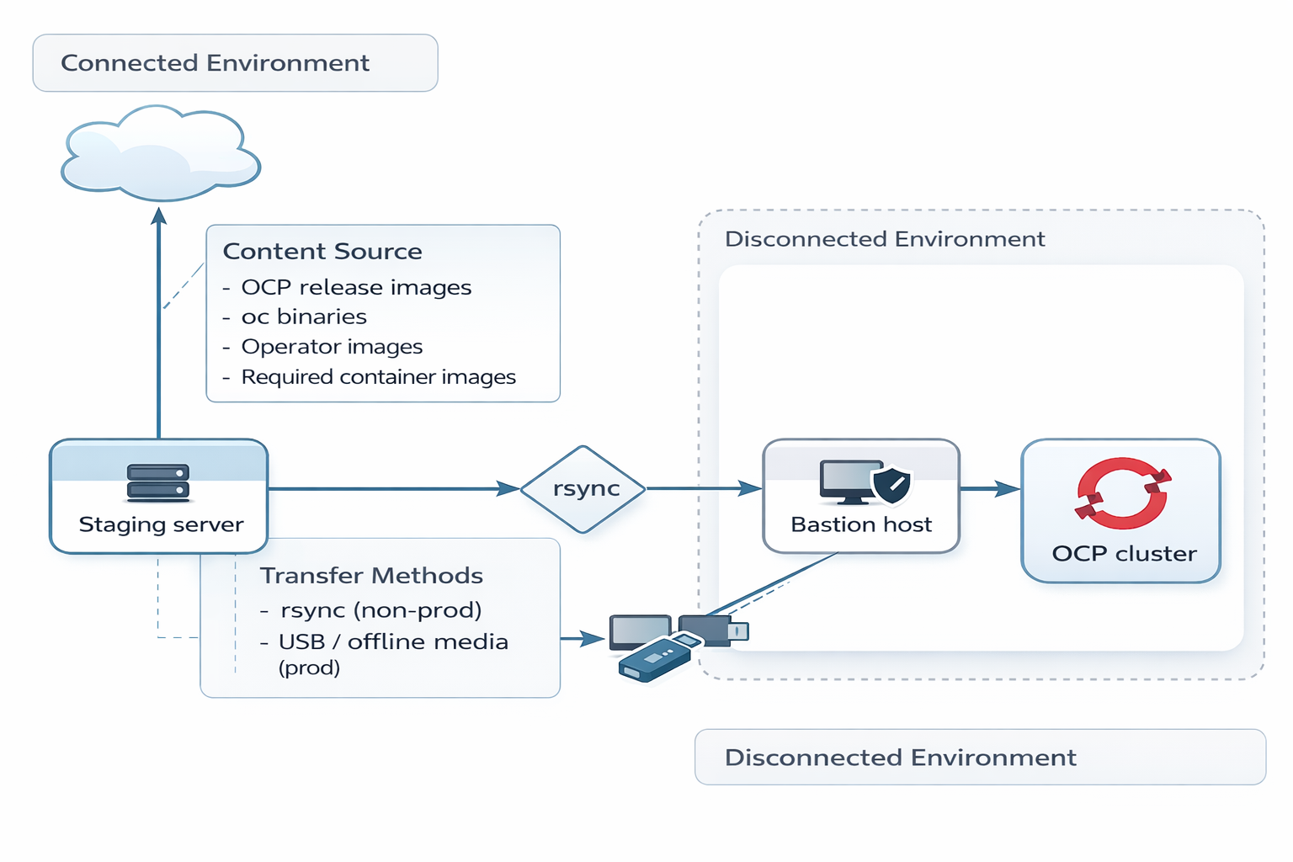

3.2.3 Cluster Topology and Node Roles
The OpenShift cluster will follow a standard highly available topology consisting of three (3) control-plane (master) nodes and three (3) worker nodes. To maintain control-plane stability and enforce proper separation of responsibilities, control-plane nodes will be configured as non-schedulable, while all application and virtualization workloads will run exclusively on worker nodes. The cluster is designed to support both containerized applications and virtual machines through OpenShift Virtualization, ensuring consistent resource isolation and predictable performance across different workload types.

3.2.3 Physical Infrastructure and High Availability Design
The cluster will be deployed across multiple physical racks designed for high availability and fault tolerance. Each rack will include dual power supplies and redundant top-of-rack (ToR) network switches to ensure resilient infrastructure. This design provides protection against rack-level failures while maintaining continuous network connectivity and overall platform availability for compute and storage workloads.

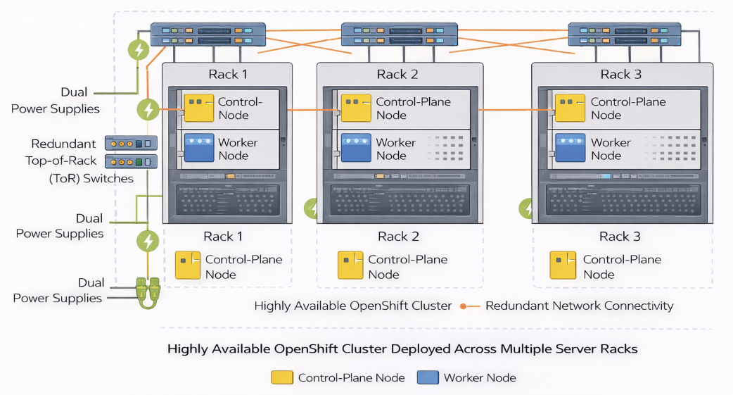

3.2.4 Network Design and Capacity Planning
From a networking perspective, a machine network CIDR of /24 is sufficient for the current cluster size; however, for future scalability—such as supporting MetalLB or additional services—a /23 CIDR is recommended. This approach ensures adequate IP address capacity while allowing for service exposure and future expansion as the environment grows.

3.2.5 Platform Storage
The platform will use Red Hat OpenShift Data Foundation (ODF) as the primary storage solution, delivering a fully integrated, software-defined storage layer for both containerized and virtualized workloads. ODF provides ReadWriteOnce (RWO) block, ReadWriteMany (RWX) file, and S3-compatible object storage, all powered by Ceph to ensure high availability, replication, and fault tolerance. Ceph replication traffic is isolated to a dedicated Layer 2 (L2) network used exclusively by worker nodes, enabling efficient east-west data flow and minimizing contention with application traffic, while control plane nodes remain excluded from storage operations.
All application and service communication is handled through the OpenShift SDN (pod network), which provides the overlay network for pod-to-pod connectivity. This separation between the pod network (overlay) and the storage replication network (underlay L2) ensures clear traffic segmentation, predictable performance, and improved fault isolation. ODF’s operator-based integration automates PV provisioning, storage class management, and lifecycle operations, while its object storage supports additional use cases such as container registry backends, backup and restore, and other S3-compatible workloads in a disconnected environment.

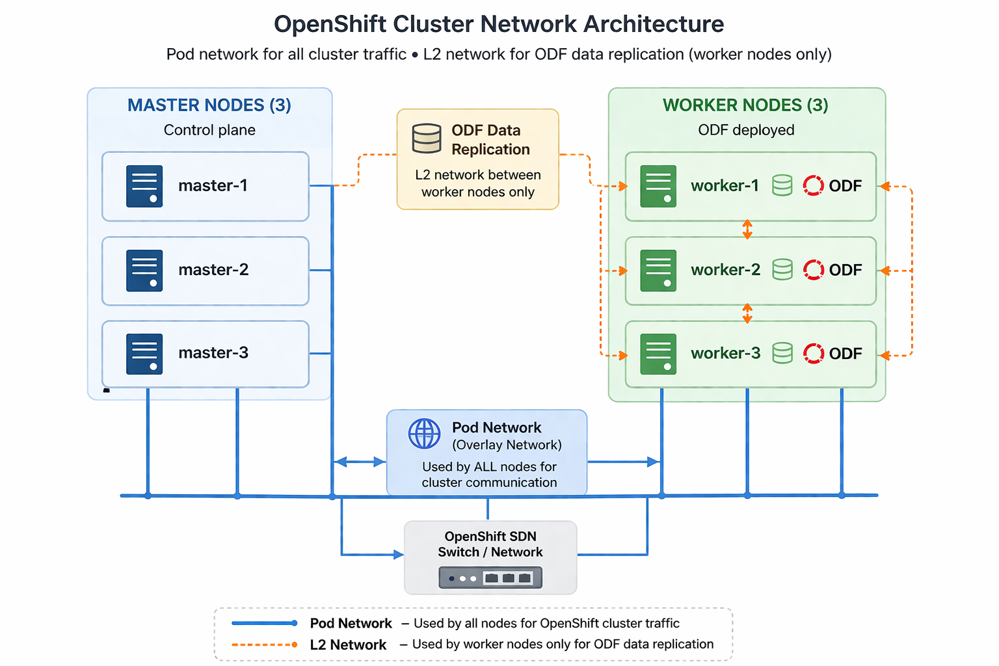

3.2.6 Load balancing
For this non-production environment, no external load balancer will be deployed. Instead, the cluster will rely on the built-in OpenShift load balancing mechanisms, where both the API VIP and Ingress VIP are managed internally within the cluster. Incoming traffic is directed to these virtual IPs, which are handled by the control plane and ingress components to route requests to the appropriate services.
This approach simplifies the architecture while still providing sufficient availability and functionality for a non-production setup. Internal load balancing ensures that API and application traffic are distributed across healthy nodes without the need for an external appliance, while maintaining alignment with OpenShift’s standard deployment model.
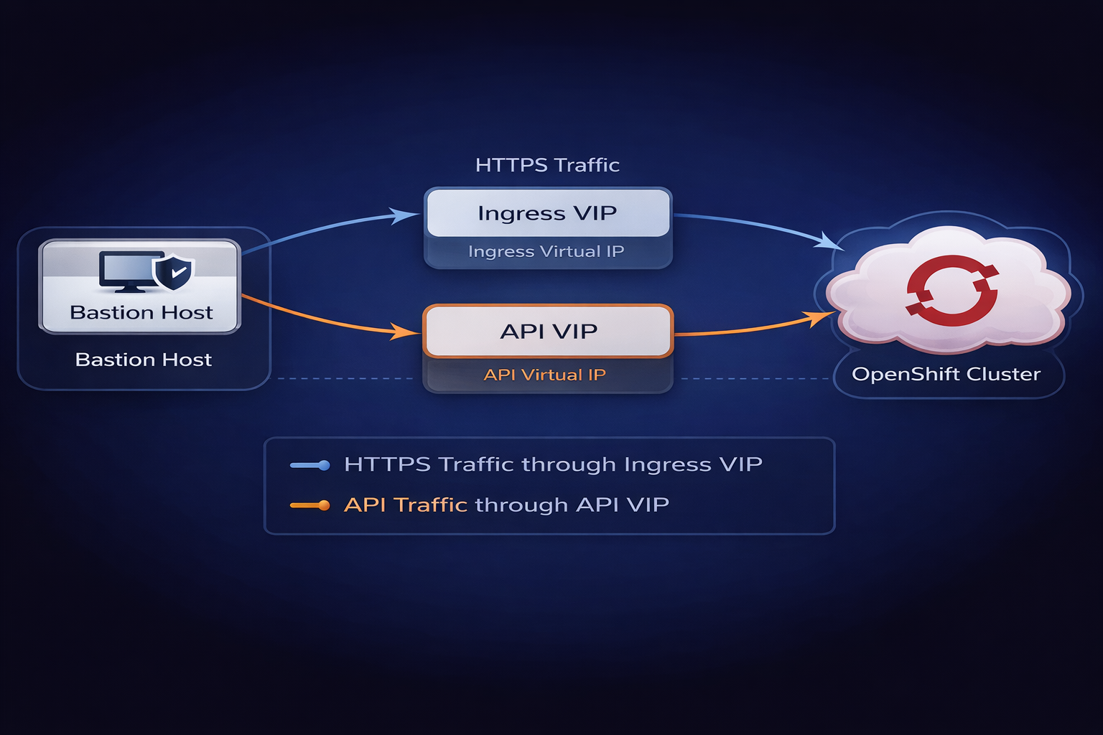

3.2.7 Software Editions and Subscriptions

The OpenShift Platform Plus subscription will be used for this deployment, providing a comprehensive and integrated Kubernetes platform that includes capabilities for application runtime, multi-cluster management, security, registry services, and data management. This subscription includes Red Hat OpenShift Container Platform for running containerized and virtualized workloads, Red Hat Advanced Cluster Management for centralized governance and lifecycle operations, Red Hat Advanced Cluster Security for vulnerability management and runtime protection, Red Hat Quay as an enterprise container registry supporting disconnected environments, and Red Hat OpenShift Data Foundation for persistent storage services. Together, these components enable a unified platform that supports scalable, secure, and highly available application deployments across the environment.

3.2.8 Future Considerations
Future enhancements will focus on automating virtual machine (VM) provisioning using Red Hat Satellite as the centralized management solution, particularly suited for disconnected environments. Satellite will provide lifecycle management, content synchronization, and template-based VM provisioning, enabling consistent and controlled deployment of VMs across the platform. By leveraging Satellite, VM images, packages, and configurations can be maintained locally without dependency on external repositories.
This approach enables standardized VM builds through pre-defined templates and host groups, with integrated IP address management and configuration handled as part of the provisioning workflow. It ensures consistency, repeatability, and compliance while simplifying operations in a disconnected environment, removing the reliance on external integrations such as Infoblox or GitOps-based provisioning.

3.3 OpenShift Cluster Deployments
The OpenShift cluster will be deployed on Dell bare metal servers using the Agent-Based Installer, with the bastion host acting as the central control point for the installation process. The installation ISO is generated locally on the bastion and hosted via a lightweight HTTP server. Each server boots from this ISO by mounting it over the network through the BMC interface (e.g., iDRAC), with the process automated using shell scripts or Ansible playbooks. Once booted, the nodes automatically initiate the installation, and deployment progress can be monitored from the bastion host. Upon completion, the cluster provides the kubeadmin credentials and console URL for initial access.
To support disconnected operations, a local container registry (Red Hat Quay) is deployed and populated with the required OpenShift release images and operators. This registry serves as the trusted image source for the cluster, ensuring independence from external registries and maintaining a consistent and controlled software supply chain. Cluster configuration and post-deployment tasks are managed directly through standard OpenShift tooling and operational procedures, keeping the design simple and aligned with the requirements of a non-production environment.

3.3.1 Node Networking Customizations
Each cluster node will be equipped with six (6) 25 Gb NIC ports, organized into bonded interfaces to provide redundancy, performance, and traffic separation. NICs will be paired and configured in mode 4 (802.3ad / LACP), with each port in a bond connected to a different upstream switch to ensure high availability and resilience against port, NIC, or switch-level failures, while enabling active-active load balancing.
bond0 is configured on both control plane (master) and worker nodes and serves as the primary MachineNetwork, carrying cluster management, API, and general node communication traffic using VLAN trunking as required. On worker nodes only, two additional bonds are defined to separate workload-specific traffic. bond1 is dedicated to virtual machine (VM) workloads, leveraging Multus with an OVS bridge (e.g., br-vmnet) created via NodeNetworkConfigurationPolicy (NNCP) to provide VLAN-based connectivity external to the OpenShift SDN pod network. bond2 is reserved exclusively for ODF storage replication traffic, using a dedicated Layer 2 network to ensure efficient, low-latency east-west data replication between worker nodes.
This architecture enforces clear separation of infrastructure, workload, and storage traffic, improving performance, fault isolation, and overall operational reliability.

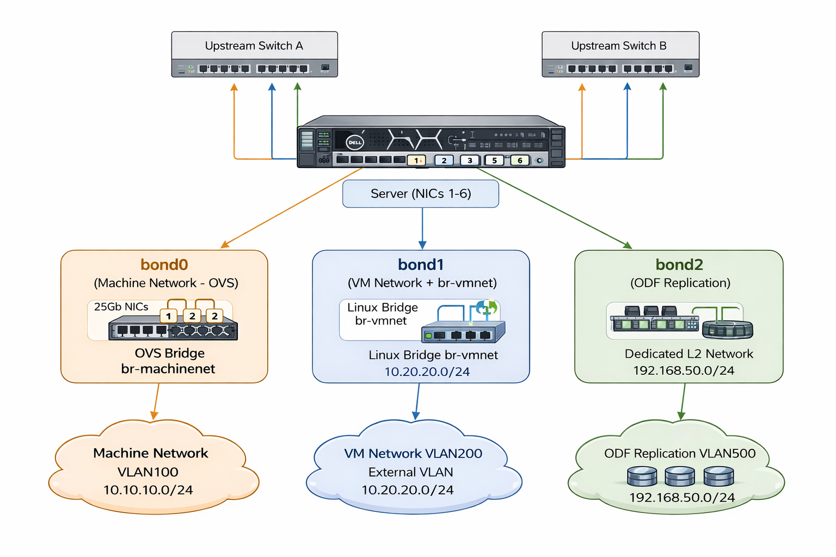

3.3.2 Bare Metal Machine Management

Using the interactive Assisted Installer is typically considered a User-Provisioned Infrastructure (UPI) installation method. In such cases, machine provisioning and lifecycle management of bare metal servers are handled manually by the cluster administrator. This differs from Installer-Provisioned Infrastructure (IPI) installations, where the OpenShift Machine API automatically provisions and manages the lifecycle of cluster nodes. As a result, UPI-based installations do not include OpenShift “Machine” objects—only “Node” objects that represent the joined hosts without enabling lifecycle management through OpenShift.

However, since the deployment method in this environment leverages the Agent-Based Installer, the behavior aligns more closely with IPI-like functionality. The Agent-Based Installer supports the creation and management of OpenShift Machine objects, enabling native lifecycle operations such as scaling, replacement, and automated reconciliation through the Machine API. This approach allows OpenShift to maintain full control over machine resources after installation, simplifying post-deployment operations like node replacement, hardware refresh, and cluster scaling, while still retaining the flexibility of a pre-provisioned bare metal environment.

3.3.2.1 Node Maintenance

The Node Maintenance Operator (NMO) will be installed. This operator must be used whenever planned maintenance needs to be performed on a cluster node. NMO provides a declarative and automated way to safely prepare a node for planned maintenance, ensuring that workloads are not disrupted during server hardware maintenance or replacement operations. NMO works by watching for NodeMaintenance CRs, which are manually created by cluster administrators. Upon detection of a NodeMaintenance CR, the operator automatically cordons the node, drains all of the pods which are then rescheduled onto other healthy nodes. After the maintenance work has been completed, the cluster administrator deletes the NodeMaintenance CR, at which point the operator will automatically restore the node to an operational state by uncordoning the node and changing it to a Schedulable status. Once the node's status has been restored to Schedulable, the Kubernetes scheduler can begin using the node as a candidate for new workloads placement.

3.3.3 Workload Availability

Within the context of the BakerHughes OCP-V environments, workload availability refers to maintaining continuous operation of VM workloads even in the event of node-level failures. Relying on manual monitoring and administrator intervention to detect and respond to such failures is neither practical nor reliable. Because node-level failures can result in data loss or corruption for stateful workloads, it is essential to ensure that a failed node is placed into a safe state (fenced) before initiating VM workload recovery (remediation).

Red Hat OpenShift on bare metal provides Machine Health Checks (MHC) to automate this process. MHC continuously monitors the health and status of machines and their corresponding nodes, leveraging the platform’s built-in mechanisms for failure detection, fencing, and automated remediation.

When a machine is identified as unhealthy—for example, if a node goes offline, fails to join the cluster within the expected timeframe, or enters a Failed phase—the Machine Health Check triggers fencing and remediation actions. These actions can integrate with systems such as Self Node Remediation (SNR) to safely recover affected workloads. In bare metal IPI (Installer-Provisioned Infrastructure) clusters, this process typically involves using out-of-band management interfaces (e.g., BMC) to perform a controlled reboot or power cycle of the affected machine, ensuring a clean recovery path for dependent workloads.

3.4 Quay container registry

The Red Hat Quay Operator will be deployed on OpenShift to provide a declarative, fully managed container registry service. The Operator automates the deployment and lifecycle management of all Quay components through the creation of a QuayRegistry custom resource (CR). This CR defines configuration parameters for core Quay services, including the Quay application pods, Clair security scanner, Redis cache, PostgreSQL database, and the object storage backend.

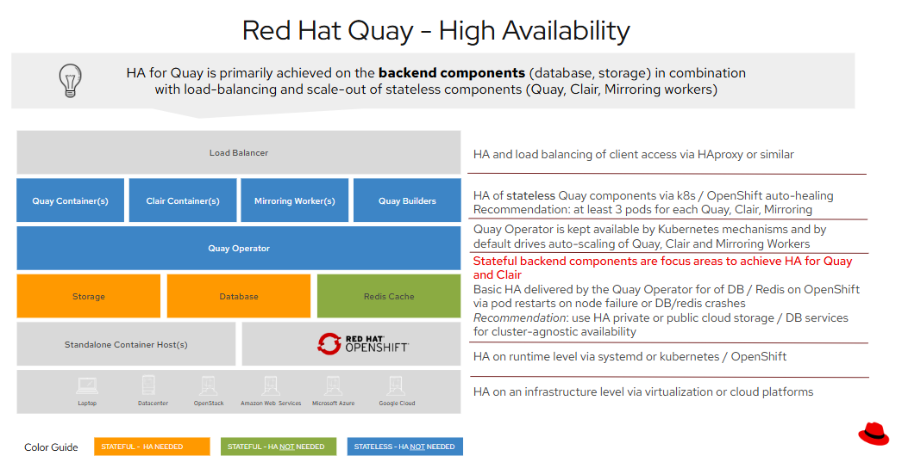

While the diagram above illustrates that both PostgreSQL and object storage must be configured for high availability (HA), in this design, the PostgreSQL database will continue to be managed by the Quay Operator, which handles automated provisioning, configuration, and health monitoring. HA for the storage layer, however, will be implemented at the infrastructure level using the ODF storage backend, ensuring data redundancy, resiliency, and consistent performance across all Quay registry and database volumes.

Although Red Hat Quay is a proven, highly available container registry capable of supporting multi-region workloads, the current design assumes a single Quay deployment, which is sufficient to serve clusters across multiple regions. However, if the decision is later made to adopt a geo-replication model, additional design considerations—such as shared object storage accessibility, centralized database connectivity, and global Redis cache synchronization—will need to be implemented to ensure cross-region consistency and performance.

4. Disaster Recovery and Site Failover
The business continuity strategy for this project is centered on in-cluster resilience and recovery, leveraging OpenShift Data Foundation (ODF) as the primary storage platform. ODF provides highly available, distributed storage with synchronous replication across worker nodes, ensuring protection against node and rack-level failures and maintaining continuous data availability for both containerized and virtualized workloads. At this stage, the solution is intentionally scoped to a single-site deployment and does not include offsite backup, cross-region replication, or automated site failover capabilities. Instead, the design focuses on enabling reliable local recovery and maintaining platform stability within the cluster.

4.1 Integration and Data Protection Strategy
Data protection is achieved through the integration of ODF with Kubernetes-native backup tooling, specifically the OpenShift API for Data Protection (OADP). This enables consistent backup and restore of Kubernetes resources, including namespaces, application configurations, and Persistent Volumes backed by ODF storage. By aligning with Kubernetes-native constructs rather than external VM-centric backup solutions, the platform ensures a more granular and application-aware recovery model.

4.2 Snapshots for Point-in-Time Recovery (Local Site)
Point-in-time recovery is implemented using ODF-backed volume snapshots, orchestrated through Kubernetes APIs and OADP workflows. These snapshots provide crash-consistent backups of persistent storage volumes and allow for rapid recovery from scenarios such as data corruption, accidental deletion, or application-level failures. Snapshot data is retained locally within the cluster, enabling efficient and fast restoration while adhering to cloud-native storage principles.

4.3 Disaster Recovery Scope (Local Site Only)
The disaster recovery scope is limited to intra-cluster recovery within the primary site. All recovery operations are performed locally, and no asynchronous replication, secondary site failover, or failback mechanisms are implemented in this design. This approach simplifies the architecture while still providing a strong level of resilience against common failure scenarios. Future enhancements may introduce multi-site disaster recovery capabilities if required by business or regulatory needs.

4.5 Namespace-Level Backups
The solution supports namespace-level backup and recovery using OADP, enabling full restoration of application environments. This includes Kubernetes manifests, configurations, and associated persistent storage. By capturing both application state and data, the platform ensures consistent and repeatable recovery of workloads within the cluster, supporting operational continuity without reliance on external backup systems.

5. Virtual Machine Workloads and Migration Planning

During the planning and discovery sessions, it was identified that the environment will initially host up to nine virtual machines within OpenShift Virtualization (OCP-Virt). These virtual machines will primarily consist of Red Hat Enterprise Linux (RHEL) systems, along with a small number of Windows-based workloads.

All virtual machines will be deployed as fresh installations within the OpenShift Virtualization environment, and no migration from an existing platform (such as AWS) is planned as part of this phase.

5.1 Virtual Machine Health Checks

In the current design model, virtual machines (VMs) that are not connected to the pod network cannot leverage liveness or readiness probes, as described in the Red Hat documentation.

However, to enhance health monitoring for such VMs, it is possible to implement a watchdog-based mechanism. This approach allows OpenShift Virtualization to detect and respond to unresponsive VMs through hardware-assisted or software-based watchdog timers. While the customer already uses LogicMonitor for infrastructure visibility, integrating a watchdog device at the VM level could complement their existing monitoring solution by enabling automated recovery actions directly within OpenShift.

6. Appendix

